Adding color in bg:

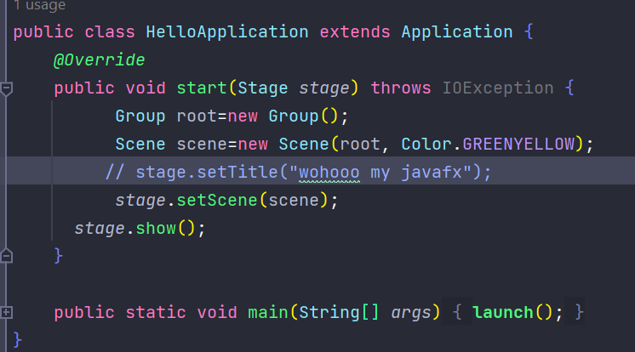

After running:

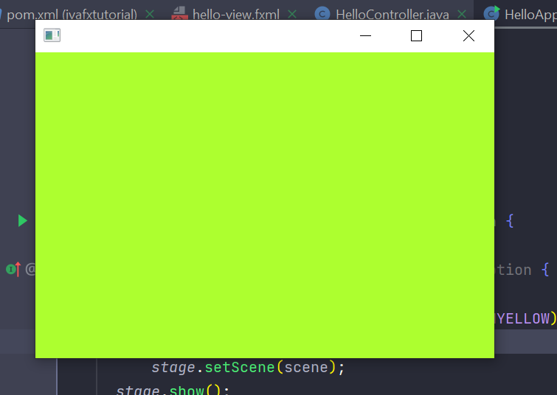

Setting fullscreen on oopening and custom option to back to window:

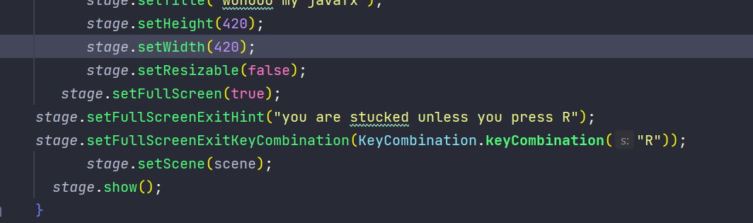

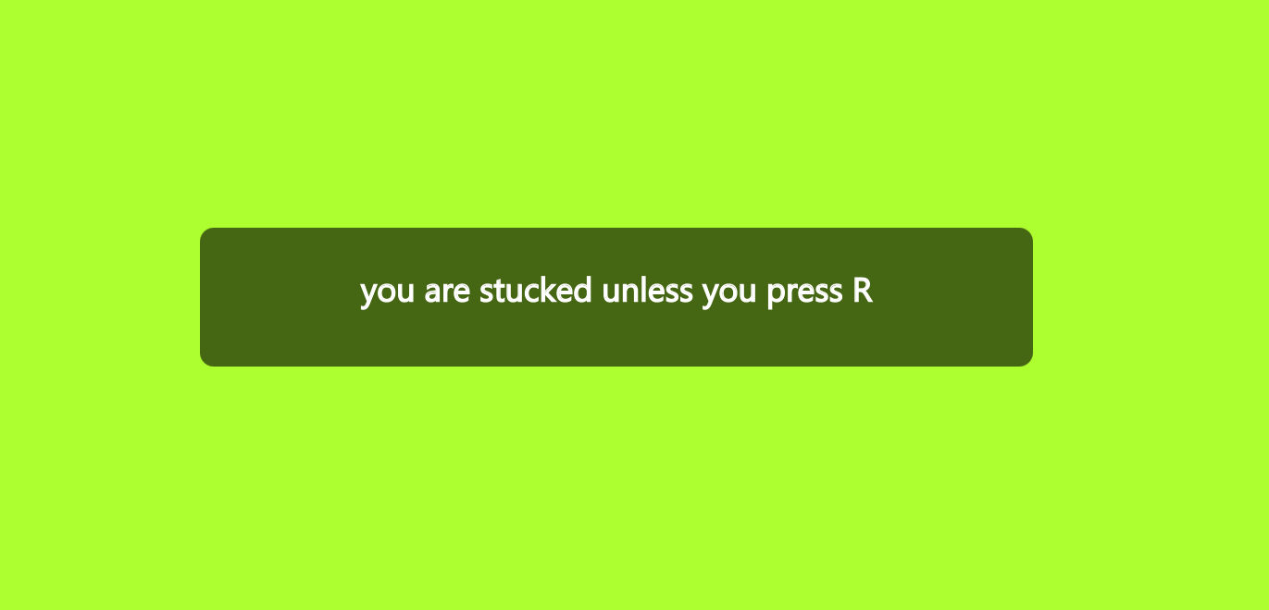

Adding title of the stage:

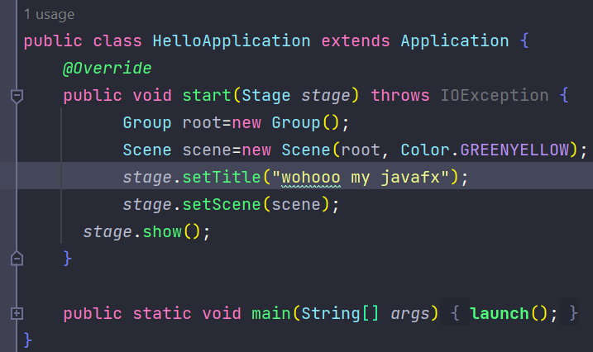

After running:

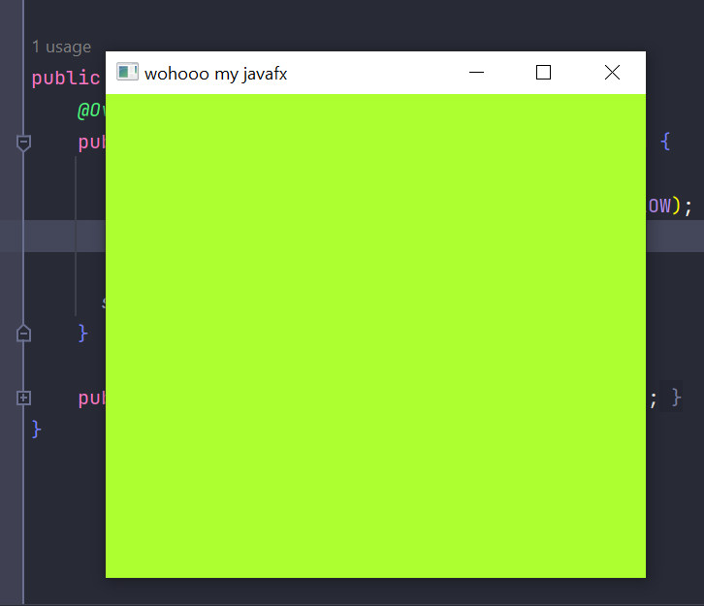

Setting height width resizable:

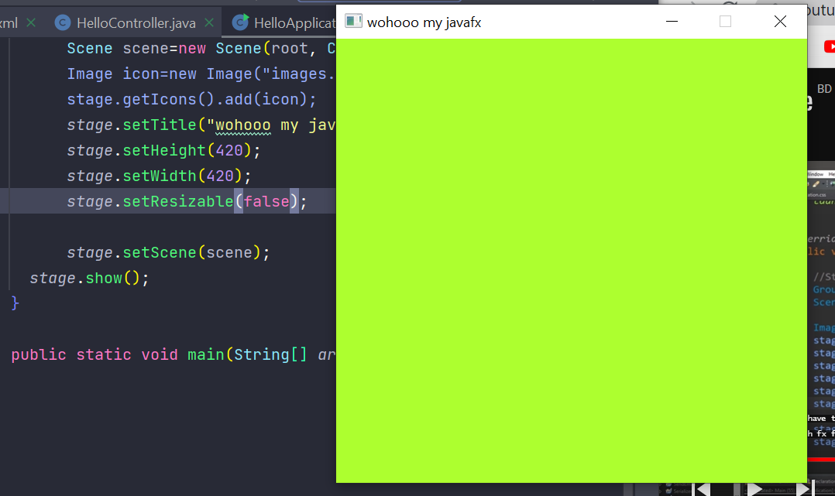

After giving a height width if the marked resizable part is given false then the stage cant be resize .

setX, setY:

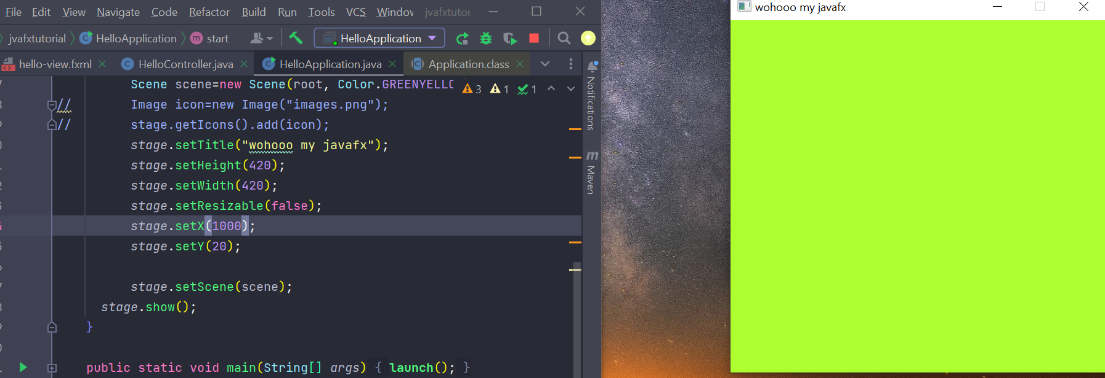

set X setY dile starting e thik oi position e stage create hbe tho pore move hbe

Important topics:

1.switching scenes:

Hellocontroller.java

Mainly this part show a pacman moving up down left right.

This controller has the part of switching scenes to next scene where there will be a circle moving like pacman

package com.example.brocodetut;

import javafx.event.ActionEvent;

import javafx.fxml.*FXML*;

import javafx.fxml.FXMLLoader;

import javafx.scene.Node;

import javafx.scene.Parent;

import javafx.scene.Scene;

import javafx.scene.control.Button;

import javafx.scene.control.Label;

import javafx.scene.shape.Arc;

import javafx.stage.Stage;

import java.io.IOException;

public class HelloController {

*@FXML*

private Button up;

*@FXML*

private Button down;

*@FXML*

private Button right;

*@FXML*

private Button left;

*@FXML*

private Arc pacman;

private double x;

private double y;

public void up(ActionEvent *e*){

pacman.setCenterY(y-=10);

}

public void down(ActionEvent *e*){

pacman.setCenterY(y+=10);

}

public void right(ActionEvent *e*){

pacman.setCenterX(x+=10);

}

public void left(ActionEvent *e*){

pacman.setCenterX(x-=10);

}

private Stage stage;

private Scene scene;

private Parent root;

*@FXML*

public void switchtocirclescene(ActionEvent *event*)throws IOException{

FXMLLoader fxmlLoader=new FXMLLoader(HelloApplication.class.getResource("circlee.fxml"));

stage=(Stage) ((Node)*event*.getSource()).getScene().getWindow();

Scene scene = new Scene(fxmlLoader.load(), 600, 600);

stage.setScene(scene);

stage.show();

}

// @FXML

// protected void onHelloButtonClick() {

// welcomeText.setText("Welcome to JavaFX Application!");

// }

}

HelloApplication.java

package com.example.brocodetut;

import javafx.application.Application;

import javafx.fxml.FXMLLoader;

import javafx.scene.Scene;

import javafx.stage.Stage;

import java.io.IOException;

public class HelloApplication extends Application {

*@Override*

public void start(Stage *stage*) throws IOException {

FXMLLoader fxmlLoader = new FXMLLoader(HelloApplication.class.getResource("hello-view.fxml"));

Scene scene = new Scene(fxmlLoader.load(), 500, 500);

*stage*.setTitle("Hello!");

*stage*.setScene(scene);

*stage*.show();

}

public static void main(String[] *args*) {

**launch**();

}

}

Circlecontrollerr.java

This is the part Of circle like the pacman, has the part of switching scene to pacman scene:

package com.example.brocodetut;

import javafx.event.ActionEvent;

import javafx.fxml.*FXML*;

import javafx.fxml.FXMLLoader;

import javafx.scene.Node;

import javafx.scene.Parent;

import javafx.scene.Scene;

import javafx.scene.control.Button;

import javafx.scene.shape.Arc;

import javafx.scene.shape.Circle;

import javafx.stage.Stage;

import java.io.IOException;

public class circlecontrollerr {

*@FXML*

private Button up1;

*@FXML*

private Button down1;

*@FXML*

private Button right1;

*@FXML*

private Button left1;

*@FXML*

private Circle circle;

private double x;

private double y;

public void up1(ActionEvent *E*){

circle.setCenterY(y-=10);

}

public void down1(ActionEvent *E*){

circle.setCenterY(y+=10);

}

public void right1(ActionEvent *E*){

circle.setCenterX(x+=10);

}

public void left1(ActionEvent *E*){

circle.setCenterX(x-=10);

}

private Stage stage;

private Scene scene;

private Parent root;

*@FXML*

public void switchtopacman(ActionEvent *event*)throws IOException{

FXMLLoader fxmlLoader=new FXMLLoader(HelloApplication.class.getResource("hello-view.fxml"));

stage=(Stage) ((Node)*event*.getSource()).getScene().getWindow();

Scene scene = new Scene(fxmlLoader.load(), 600, 600);

stage.setScene(scene);

stage.show();

}

}

******must notice:

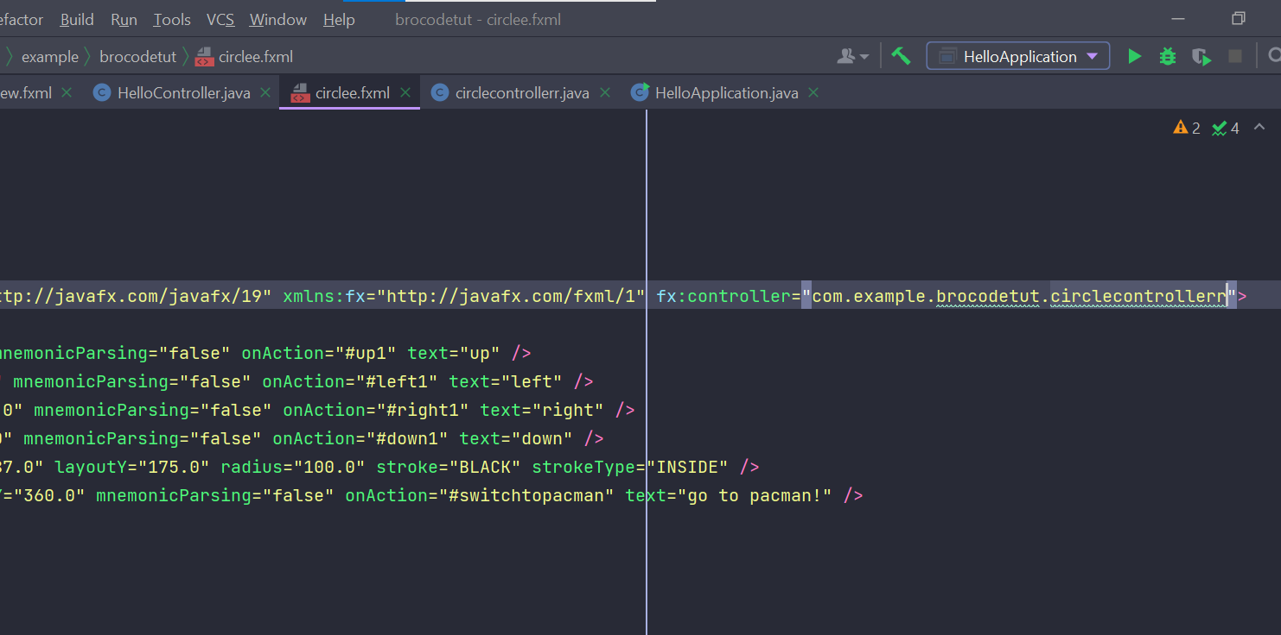

Circle.fxml e must fx:controller e giye path change kre dite hbe

Second scene er jnno controller file ar fxml file ei folder gula te khulte hbe

